Outlier Treatments
Instructions:
Please share your answers filled inline in the word document. Submit code files wherever applicable.
Please ensure you update all the details:
Name: __G Rupak_______________________
Batch Id: _______________________
Topic: Data Pre-Processing

Problem Statement:
Most of the datasets have extreme values or exceptions in their observations. These values affect the predictions (Accuracy) of the model in one way or the other, removing these values is not a very good option. For these types of scenarios, we have various techniques to treat such values.
Refer: https://360digitmg.com/mindmap-data-science

- Prepare the dataset by performing the preprocessing techniques, to treat the outliers.

# importing the libraries
import pandas as pd
import numpy as np
import seaborn as sns

# loading the data sets
df = pd.read_csv("D:/Data Science/ASSIGNMENT/Assignments 3/DataSets/boston_data.csv")
df.dtypes

# let's find outliers in 14 columns
sns.boxplot(df.crim)
sns.boxplot(df.zn)
sns.boxplot(df.indus) # no outlier in indus column
sns.boxplot(df.chas)
sns.boxplot(df.nox)#no outlier in nox column
sns.boxplot(df.rm)
sns.boxplot(df.age)# no outlier in age column
sns.boxplot(df.dis)
sns.boxplot(df.rad)# no outlier in rad column
sns.boxplot(df.tax)# no outlier in tax column
sns.boxplot(df.ptratio)
sns.boxplot(df.black)
sns.boxplot(df.lstat)
sns.boxplot(df.medv)

# Detection of outliers (find limits for crim based on IQR)
IQR = df['crim'].quantile(0.75) - df['crim'].quantile(0.25)
lower_limit = df['crim'].quantile(0.25) - (IQR * 1.5)
upper_limit = df['crim'].quantile(0.75) + (IQR * 1.5)

############### 1. Remove (let's trim the dataset) ################
# Trimming Technique
# let's flag the outliers in the data set
outliers_df = np.where(df['crim'] > upper_limit, True, np.where(df['crim'] < lower_limit, True, False))
df_trimmed = df.loc[~(outliers_df), ]
df.shape, df_trimmed.shape

# let's explore outliers in the trimmed dataset
sns.boxplot(df_trimmed.crim)
# there are still outlier

############### 2.Replace ###############
# Now let's replace the outliers by the maximum and minimum limit
df['dfcrim_replaced'] = pd.DataFrame(np.where(df['crim'] > upper_limit, upper_limit, np.where(df['crim'] < lower_limit, lower_limit, df['crim'])))
sns.boxplot(df.dfcrim_replaced)
# we see no outiers.

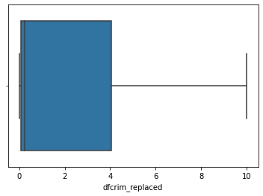

############### 3. Winsorization ###############
from feature_engine.outliers import Winsorizer
winsor = Winsorizer(capping_method='iqr', # choose IQR rule boundaries or gaussian for mean and std
tail='both', # cap left, right or both tails
fold=1.5,
variables=['zn'])
df_t = winsor.fit_transform(df[['zn']])

# we can inspect the minimum caps and maximum caps
# winsor.left_tail_caps_, winsor.right_tail_caps_

# lets see boxplot
sns.boxplot(df_t.zn)
we see no outliers.
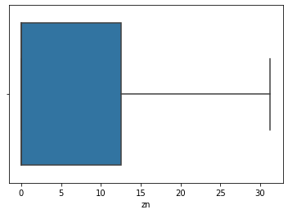
# Detection of outliers (find limits for chas based on IQR)
IQR = df['chas'].quantile(0.75) - df['chas'].quantile(0.25)
lower_limit = df['chas'].quantile(0.25) - (IQR * 1.5)
upper_limit = df['chas'].quantile(0.75) + (IQR * 1.5)
############### 1. Remove (let's trim the dataset) ################
# Trimming Technique
# let's flag the outliers in the data set
outliers_df = np.where(df['chas'] > upper_limit, True, np.where(df['chas'] < lower_limit, True, False))
df_trimmed = df.loc[~(outliers_df), ]
df.shape, df_trimmed.shape
# let's explore outliers in the trimmed dataset
sns.boxplot(df_trimmed.chas)
# chas only have 0 and 1 values.

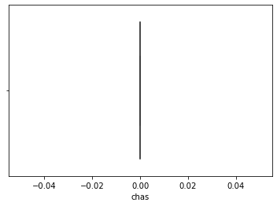
# Detection of outliers (find limits for rm based on IQR)
IQR = df['rm'].quantile(0.75) - df['rm'].quantile(0.25)
lower_limit = df['rm'].quantile(0.25) - (IQR * 1.5)
upper_limit = df['rm'].quantile(0.75) + (IQR * 1.5)
############### 1. Remove (let's trim the dataset) ################
# Trimming Technique
# let's flag the outliers in the data set
outliers_df = np.where(df['rm'] > upper_limit, True, np.where(df['rm'] < lower_limit, True, False))
df_trimmed = df.loc[~(outliers_df), ]
df.shape, df_trimmed.shape

# let's explore outliers in the trimmed dataset
sns.boxplot(df_trimmed.rm)
# there are still outlier

############### 2.Replace ###############
# Now let's replace the outliers by the maximum and minimum limit
df['dfrm_replaced'] = pd.DataFrame(np.where(df['rm'] > upper_limit, upper_limit, np.where(df['rm'] < lower_limit, lower_limit, df['rm'])))
sns.boxplot(df.dfrm_replaced)
# there are no outlier.

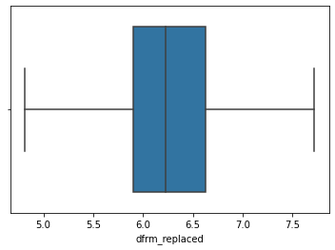

# Detection of outliers (find limits for rm based on IQR)
IQR = df['dis'].quantile(0.75) - df['dis'].quantile(0.25)
lower_limit = df['dis'].quantile(0.25) - (IQR * 1.5)
upper_limit = df['dis'].quantile(0.75) + (IQR * 1.5)

############### 1. Remove (let's trim the dataset) ################
# Trimming Technique
# let's flag the outliers in the data set
outliers_df = np.where(df['dis'] > upper_limit, True, np.where(df['dis'] < lower_limit, True, False))
df_trimmed = df.loc[~(outliers_df), ]
df.shape, df_trimmed.shape

# let's explore outliers in the trimmed dataset
sns.boxplot(df_trimmed.dis)
# there are still outlier

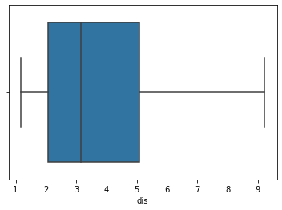
# Detection of outliers (find limits for rm based on IQR)
IQR = df['ptratio'].quantile(0.75) - df['ptratio'].quantile(0.25)
lower_limit = df['ptratio'].quantile(0.25) - (IQR * 1.5)
upper_limit = df['ptratio'].quantile(0.75) + (IQR * 1.5)

############### 1. Remove (let's trim the dataset) ################
# Trimming Technique
# let's flag the outliers in the data set
outliers_df = np.where(df['ptratio'] > upper_limit, True, np.where(df['ptratio'] < lower_limit, True, False))
df_trimmed = df.loc[~(outliers_df), ]
df.shape, df_trimmed.shape

# let's explore outliers in the trimmed dataset
sns.boxplot(df_trimmed.ptratio)
# there are no outlier.

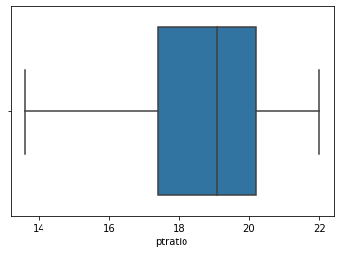

# Detection of outliers (find limits for black based on IQR)
IQR = df['black'].quantile(0.75) - df['black'].quantile(0.25)
lower_limit = df['black'].quantile(0.25) - (IQR * 1.5)
upper_limit = df['black'].quantile(0.75) + (IQR * 1.5)

############### 1. Remove (let's trim the dataset) ################
# Trimming Technique
# let's flag the outliers in the data set
outliers_df = np.where(df['black'] > upper_limit, True, np.where(df['black'] < lower_limit, True, False))
df_trimmed = df.loc[~(outliers_df), ]
df.shape, df_trimmed.shape
# let's explore outliers in the trimmed dataset
sns.boxplot(df_trimmed.black)
# there are still outlier
(WERE ARE NOT USING REPLACE BECAUSE IT JUST REPLACE OUTLIER. BUT IT LEAVES NO VALUE IN BOX PLOT.)
############## 3. Winsorization ###############
from feature_engine.outliers import Winsorizer
winsor = Winsorizer(capping_method='iqr', # choose IQR rule boundaries or gaussian for mean and std
tail='both', # cap left, right or both tails
fold=1.5,
variables=['black'])
df_t = winsor.fit_transform(df[['black']])
# we can inspect the minimum caps and maximum caps
# winsor.left_tail_caps_, winsor.right_tail_caps_
# lets see boxplot
sns.boxplot(df_t.black)

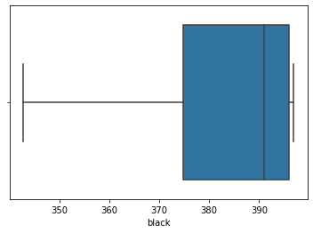
# Detection of outliers (find limits for lstat based on IQR)
IQR = df['lstat'].quantile(0.75) - df['lstat'].quantile(0.25)
lower_limit = df['lstat'].quantile(0.25) - (IQR * 1.5)
upper_limit = df['lstat'].quantile(0.75) + (IQR * 1.5)

############### 1. Remove (let's trim the dataset) ################
# Trimming Technique
# let's flag the outliers in the data set
outliers_df = np.where(df['lstat'] > upper_limit, True, np.where(df['lstat'] < lower_limit, True, False))
df_trimmed = df.loc[~(outliers_df), ]
df.shape, df_trimmed.shape

# let's explore outliers in the trimmed dataset
sns.boxplot(df_trimmed.lstat)
# there are no outlier.
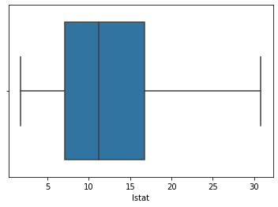
# Detection of outliers (find limits for medv based on IQR)
IQR = df['medv'].quantile(0.75) - df['medv'].quantile(0.25)
lower_limit = df['medv'].quantile(0.25) - (IQR * 1.5)
upper_limit = df['medv'].quantile(0.75) + (IQR * 1.5)

############### 1. Remove (let's trim the dataset) ################
# Trimming Technique
# let's flag the outliers in the data set
outliers_df = np.where(df['medv'] > upper_limit, True, np.where(df['medv'] < lower_limit, True, False))
df_trimmed = df.loc[~(outliers_df), ]
df.shape, df_trimmed.shape
# let's explore outliers in the trimmed dataset
sns.boxplot(df_trimmed.medv)
# there are still outlier.

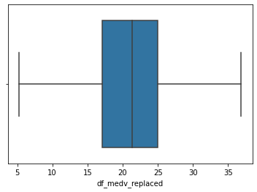


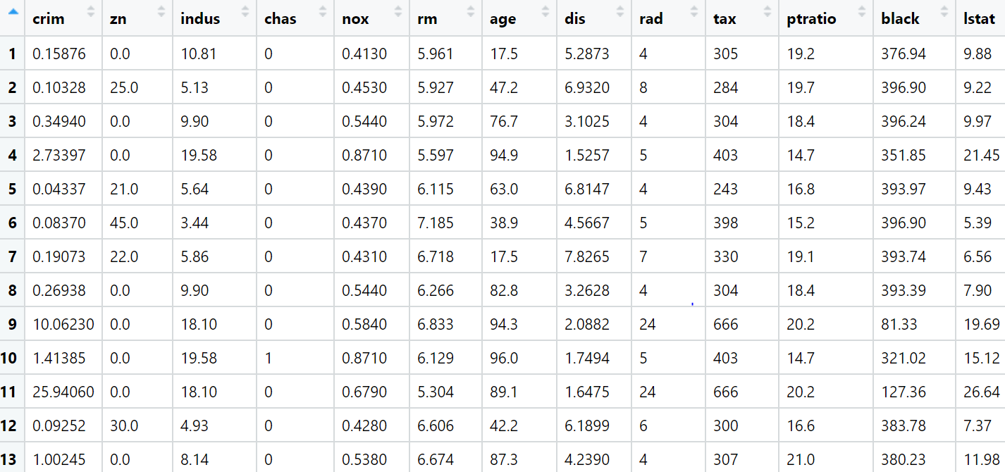

Hints:
For each assignment, the solution should be submitted in the below format
- Work on each feature to create a data dictionary as displayed in the image displayed below: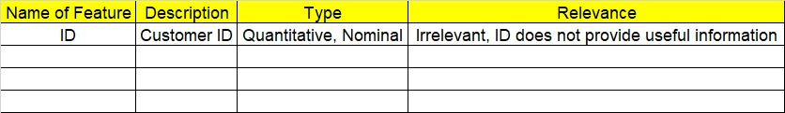
- Hint: Boston dataset is publicly available. Refer to Boston.csv file.
- Research and perform all possible steps for obtaining solution
- All the codes (executable programs) should execute without errors
- Code modularization should be followed
- Each line of code should have comments explaining the logic and why you are using that function
- Detailed explanation of your approach is mandatory

Grading Guidelines:
Note: 1. An Assignment submission is considered complete only when successful executable code(s), and documentation explaining the applied solution and results are provided. Failing to submit either of them will be considered an invalid submission and will not be considered for evaluation.
2. Assignments submitted after the deadline date will affect your grades.

Grading:
Ans | Date |  |  | Ans | Date
Correct | On time | A | 100
80% & above | On time | B | 85 | Correct | Late
50% & above | On time | C | 75 | 80% & above | Late
50% & below | On time | D | 65 | 50% & above | Late
 |  | E | 55 | 50% & below
Copied/No Submission |  | F | 45

- Grade A: (>= 90): When all assignments are submitted on or before the given deadline date
- Grade B: (>= 80 and < 90):
  - When assignments are submitted on time but less than 80% of questions asked in assignments are completed. (or)
  - All assignments were submitted, however, after the given deadline

- Grade C: (>= 70 and < 80):
  - When assignments are submitted on time but less than 50% of questions asked in assignments are completed. (or)
  - Less than 80% of questions asked in assignments are submitted after the deadline

- Grade D: (>= 60 and < 70): Assignments submitted after the Deadline and with 50% or less of questions

- Grade E: (>= 50 and < 60):
  - Less than 30% of questions asked in the assignments are submitted after the deadline (OR)
  - Less than 30% of questions asked in the assignments are submitted before deadline

- Grade F: (< 50): Copied submission or No submission

